Haidy Essam Mostsfa Elhamady

Lab 3 Bash

1-Write a script called mycase, using the case utility to checks the type of character  
entered by a user:  
a. Upper Case.  
b. Lower Case.  
c. Number.  
d. Nothing

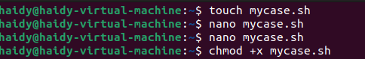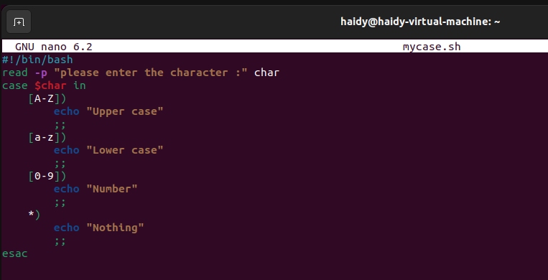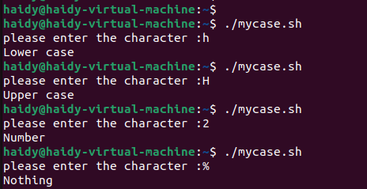

2- Enhanced the previous script, by checking the type of string entered by a user:  
a. Upper Cases.  
b. Lower Cases.  
c. Numbers.  
d. Mix.  
e. Nothing.

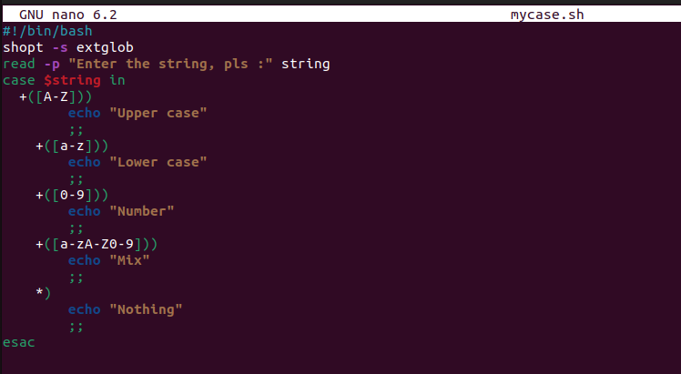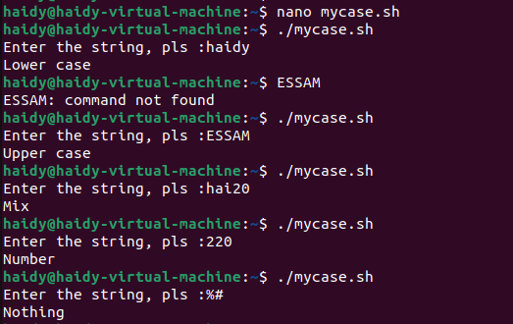

3-Write a script called mychmod using for utility to give execute permission to all files and directories in your home directory.

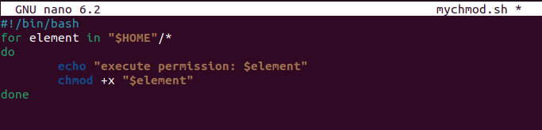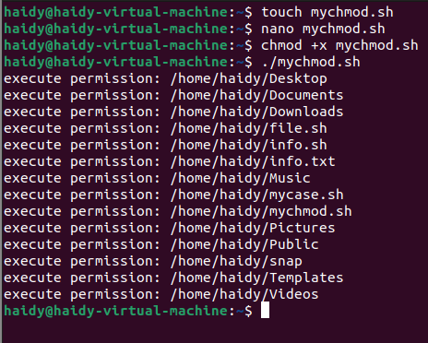

4-Write a script called mybackup using for utility to create a backup of only files in your home directory

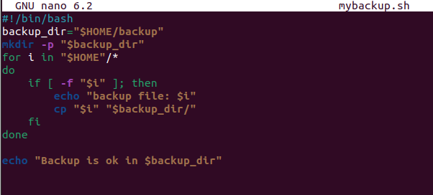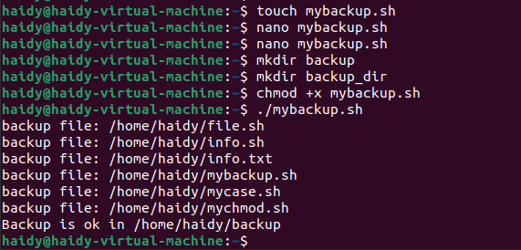

5-Write a script called mymail using for utility to send a mail to all users in the system.  
Note: write the mail body in a file called mtemplate

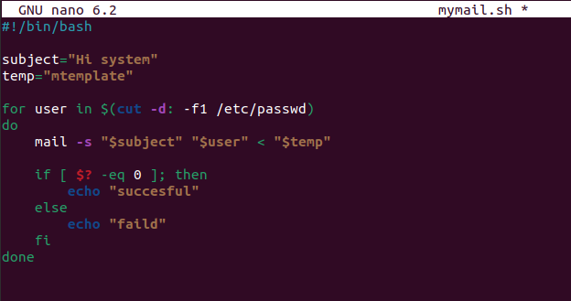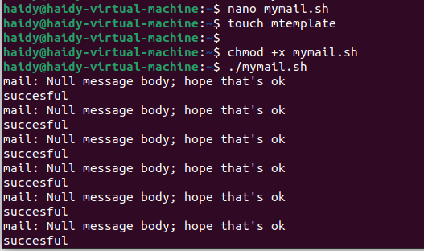

6-Write a script called chkmail to check for new mails every 10 seconds. Note: mails are saved in /var/mail/username.

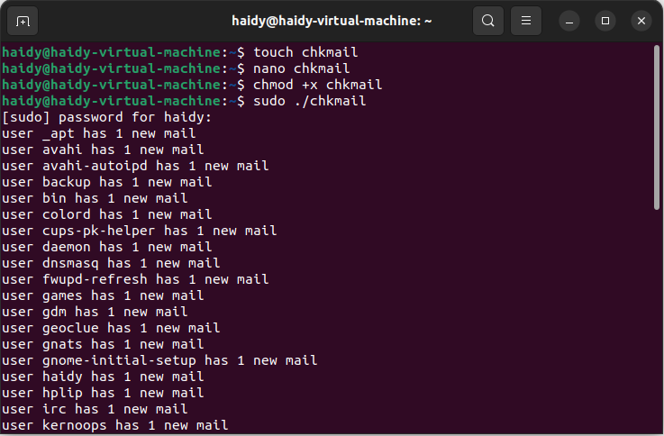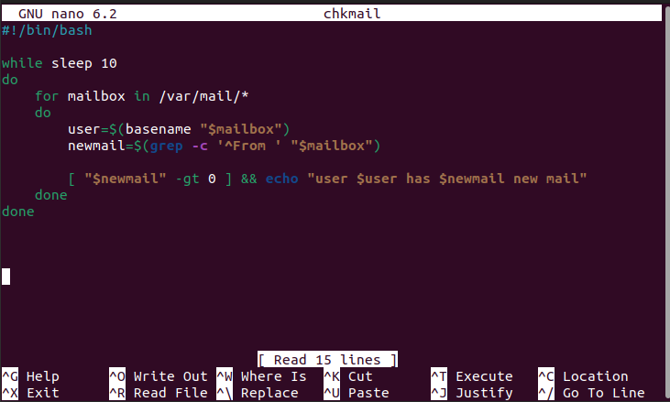

7-What is the output of the following script  
typeset –i n1  
typeset –i n2  
n1=1  
n2=1  
while test $n1 –eq $n2  
do  
n2=$n2+1  
print $n1  
if [ $n1 –gt $n2 ]  
then  
break  
else  
continue  
fi  
n1=$n1+1  
print $n2  
done

**It doesn’t work and i modified it and the output=1**

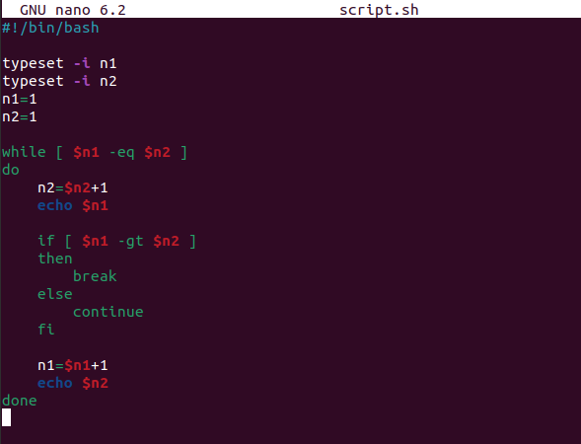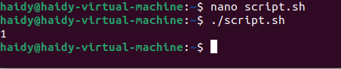

8-Create the following menu:  
a. Press 1 to ls  
b. Press 2 to ls –a  
c. Press 3 to exit  
Using select utility then while utility

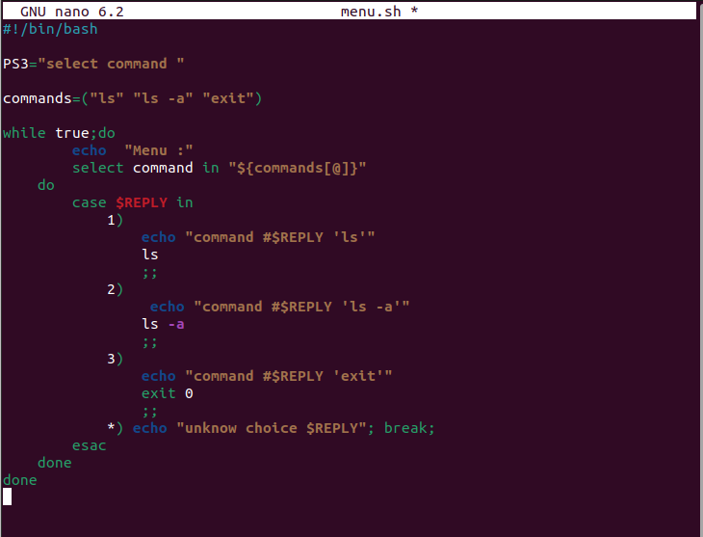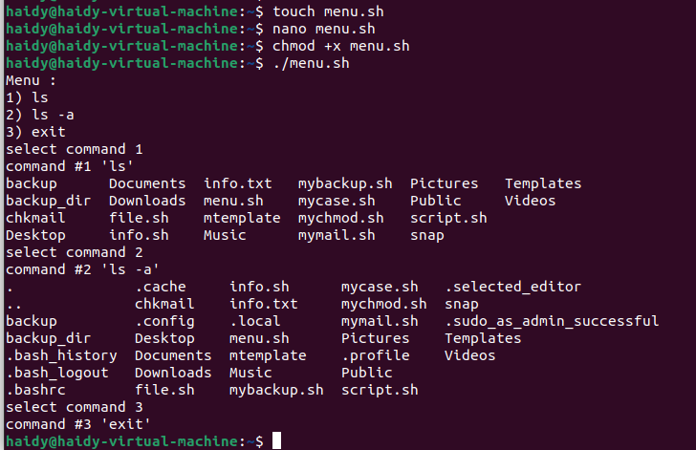

9- Write a script called myarr that ask a user how many elements he wants to enter in an array, fill the array and then print it

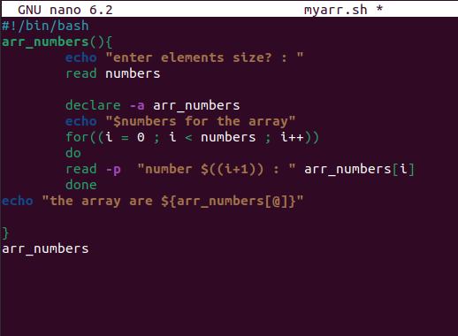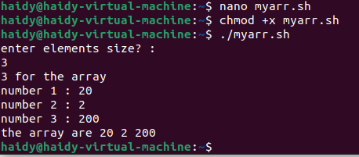

10- Write a script called myavg that calculate average of all numbers entered by a user.  
Note: use arrays

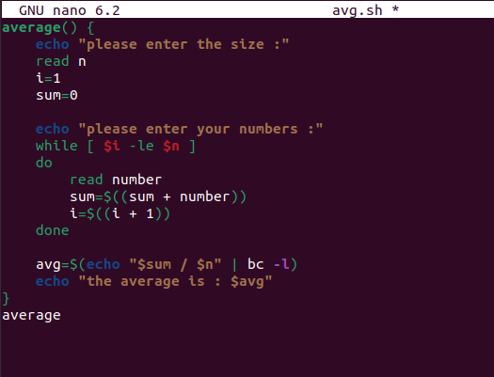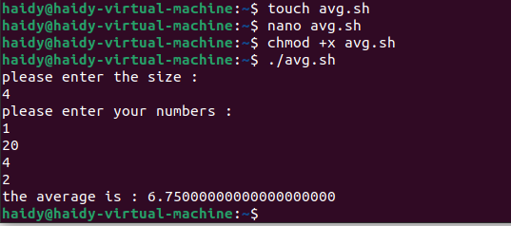

11- Write a function called mysq that calculate square if its argument

